|  |  |  |  |  |
| --- | --- | --- | --- | --- |
| **Test** | **Description** | **Expected outcome** | **Actual outcome** | **Screen dump** |
| Start game | Load the game and see if met with the splash screen | The game loads | The game loaded | Ss1  Ss2 |
| Start game part ii | The splash screen requires that the s key is pressed to start the game. This test is to see if the s key starts the game | The s key will start the game(loading the rocket and the 55 aliens) | the game started | Ss3 |
| Left movement | Press the left arrow key to see if the rocket moves to the left | The rocket moves to the left | The rocket moved to the left | Ss4 |
| Right movement | Press the right arrow key to see if the rocket moves to the right | The rocket moves to the right | The rocket moved to the right | Ss5 |
| Missile fire | The missile fires when the space bar is pressed | The missile will fire | The missile fired and continued to move in the y position | Ss6 |
| Alien deletion | Fire a missile at the alien block and see if one of the aliens disappears | Only the alien that is hit will disappear and the missile will also disappear | The alien was deleted and so was the missile | Ss7 |
| Alien movement | The alien moves to the left most positon then drops down the screen by 8 pixels | All 55 aliens should move down the screen by the same amount | All 55 aliens moved down the screen after hitting the left boundary | Ss8 |
| Alien movement part ii | The aliens should move to the right most position then drop down the screen by 8 pixels | All aliens move down the screen after hitting the right boundary | All 55 aliens moved down the screen by the same amount at the right most position | Ss9 |
| Score update | After an alien invader has been hit the score should update | The score should go up by 100 points after the invader has been killed | The score went up by the amount stated | Ss10 |
| Aliens at same level as the player | When the aliens hit the same y position as the player the game should end and the game ended screen should appear | The game should end and the ended screen should appear | The game ended when the aliens hit the same y position as the player and the games ended screen appeared allowing the user to | Ss11  Ss12 |
| The endscreen | When on the endscreen two options are given the restart option and the exit option | The game should restart when the r key is pressed sending the user to the start screen for them to start the game again | The game did go back to the start screen allowing the user to restart the game | Ss13  Ss14 |
| The endscreen part ii | When on the endscreen two options are given the restart option and the exit option | When the x key is pressed on the endscreen then the game should close completely with no other game options available | The game quit and the game screen closed | Ss15  Ss16 |

During the testing these are bugs that I found while the game was running

The evidence for the bugs are shown at the end and the code that has been changed has been commented on and place inside the table

|  |  |  |  |
| --- | --- | --- | --- |
| **Bug no.** | **Description** | **Fix** | **Screen dump of bug (and now working game)** |
| Bug 1 | When the game was rest at the end of the game the score remained the same the score before was 300 to see if it was fixed when invaders were shot I shot 3 so the score should have been 300 not the 600 that was showing | I moved the self.score from the initialize block to the block that initialized the game variables | Ss17  Ss18  Ss19 |
| Bug 2 | During the game I noticed that when the missile was fired it dint shoot from the middle of the player image where the turret is and instead shot from the left of it | Took into consideration the width of the rocket in the equation to work out the coordinates for where the missile shoots from | Ss20  Ss21 |

Screen Dumps to show working game

Before the game has been opened (ss1)

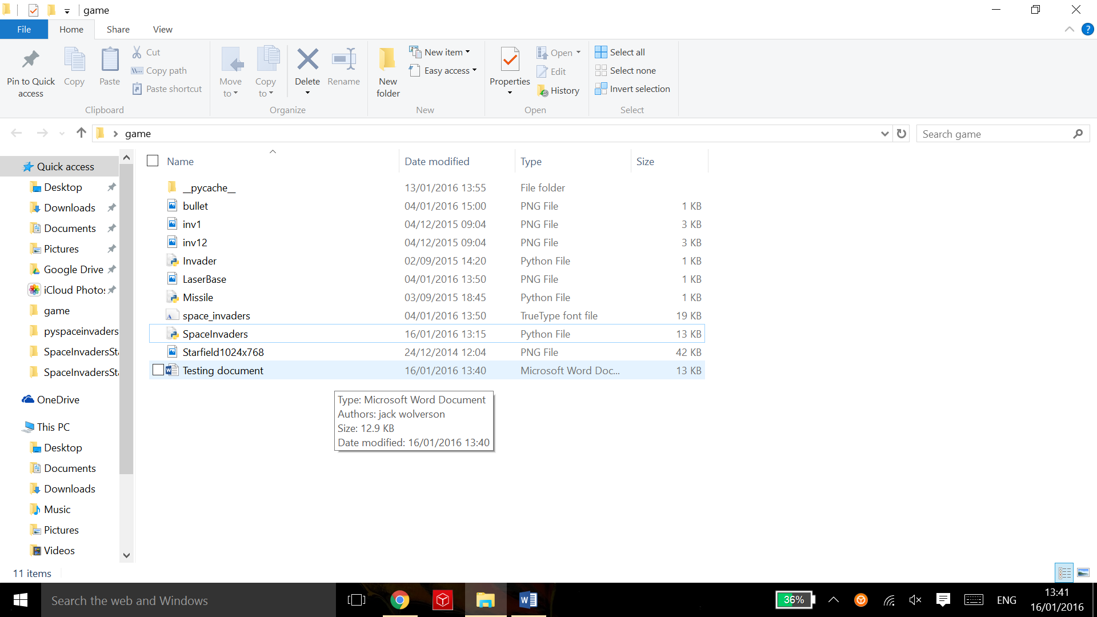

The game opening successfully (ss2)

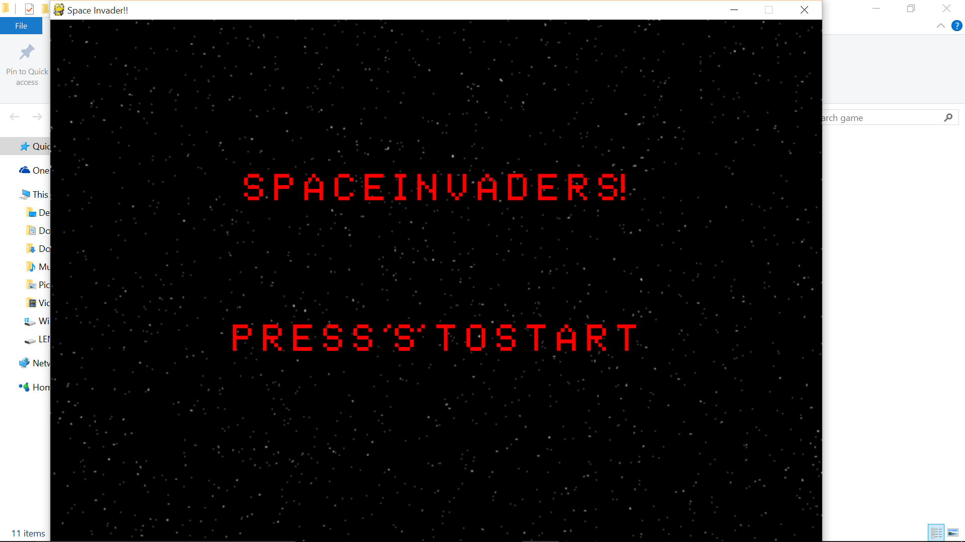

After pressing the‘s’ key to start the game (ss3)

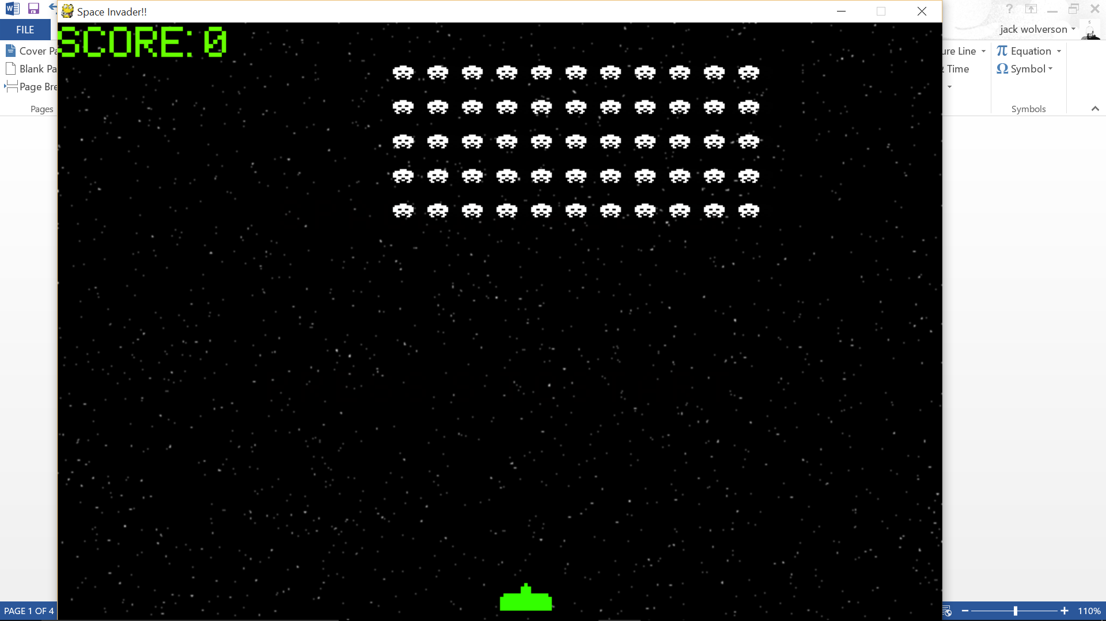

Moving the player to the left (ss4)

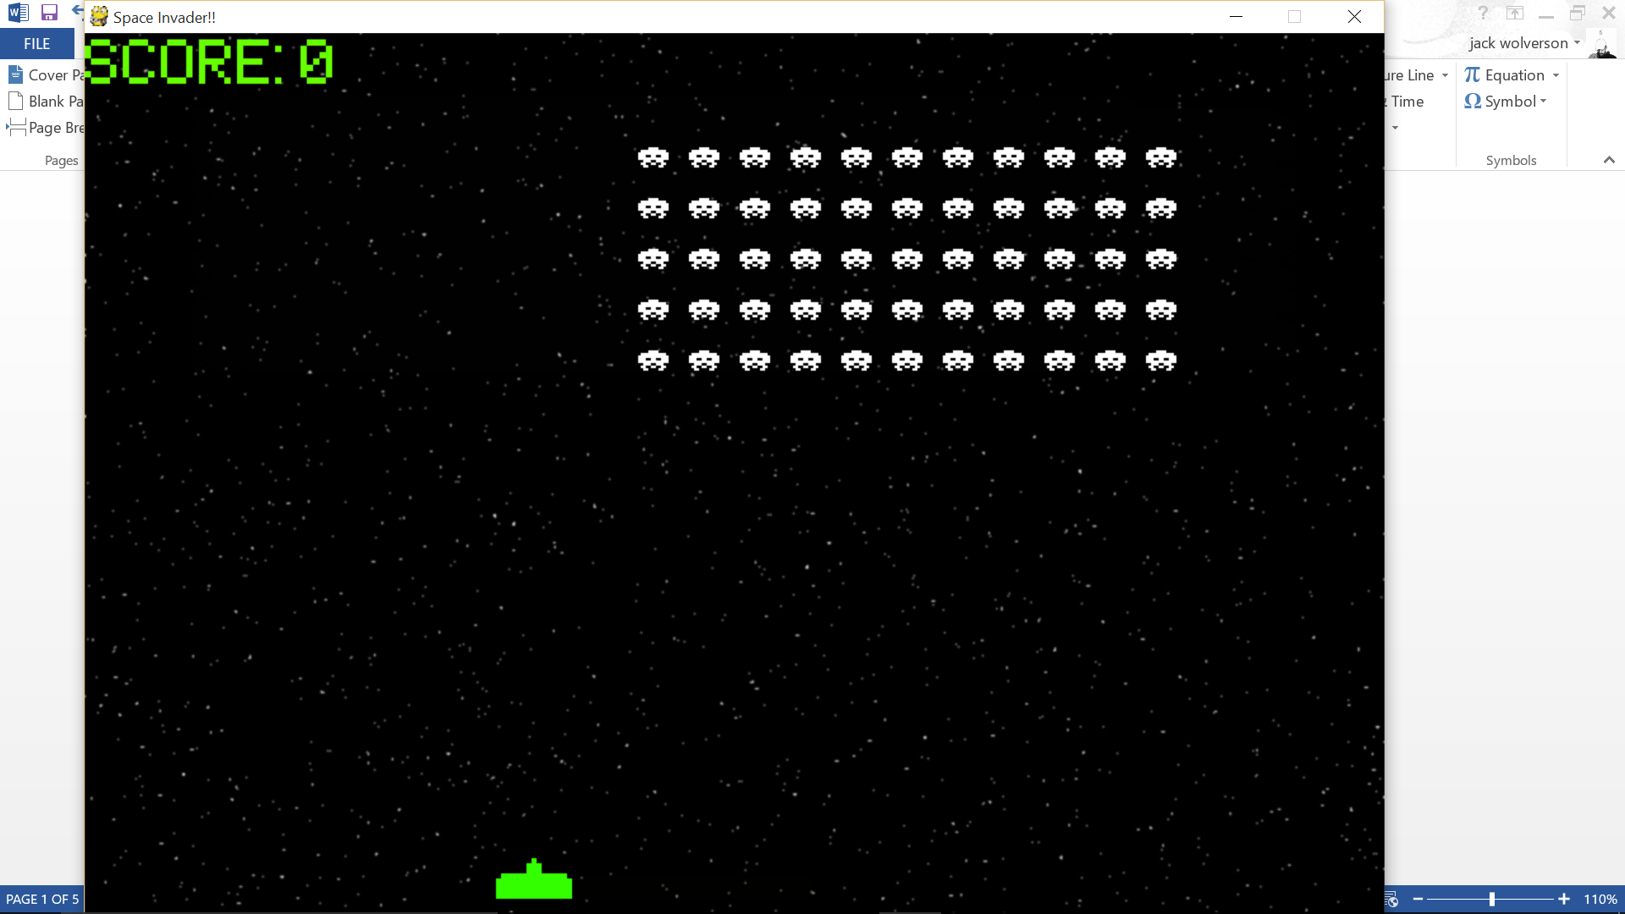

Moving the player to the right (ss5)

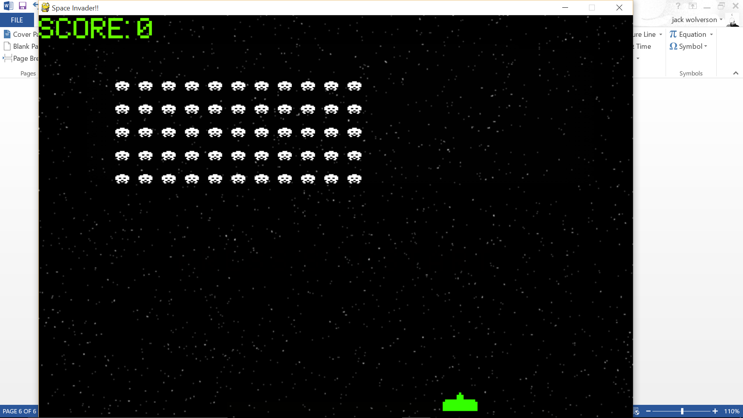

Firing the missile with the space bar (ss6)

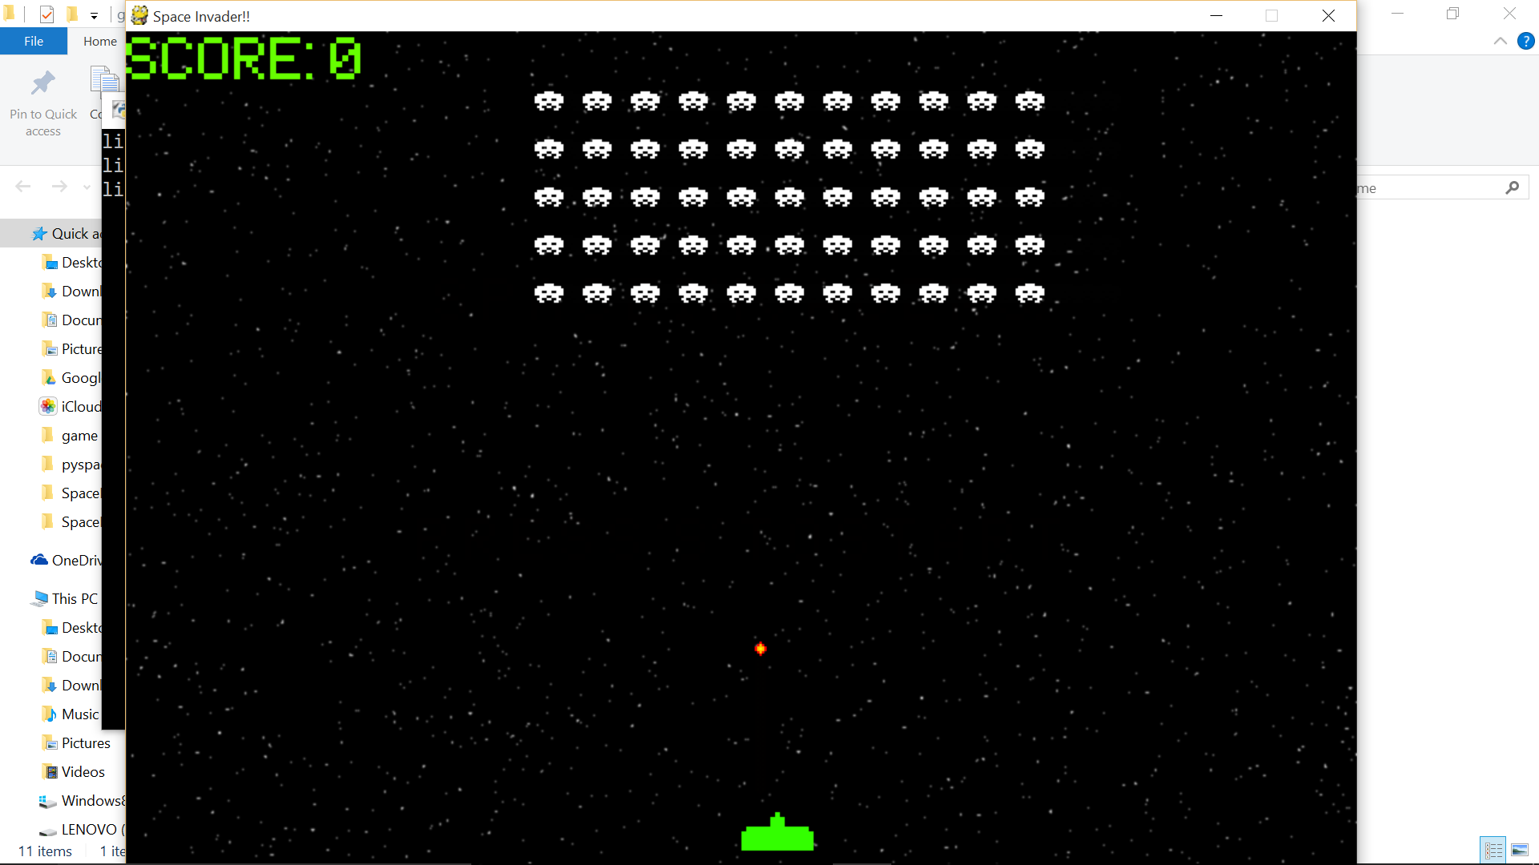

The alien that the missile hit deleted (ss7)

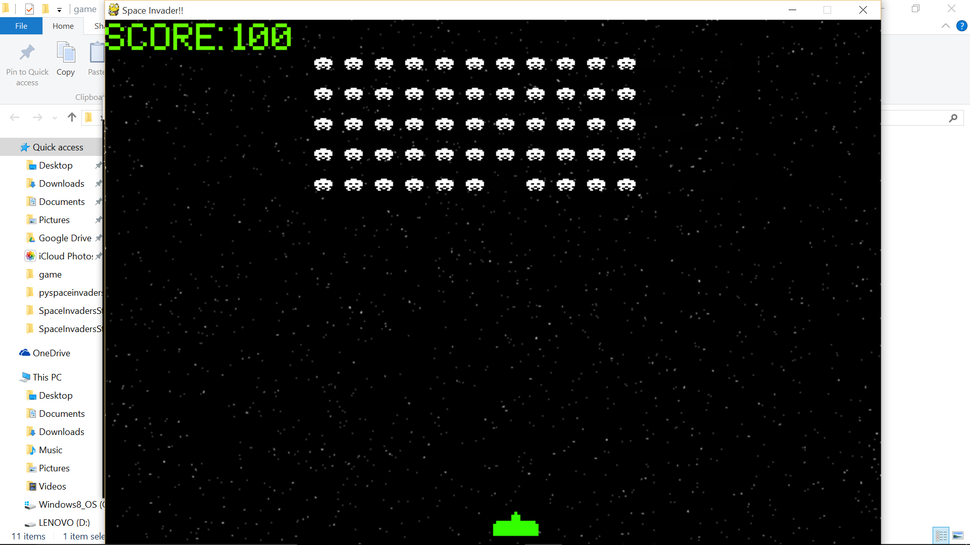

The aliens further down the screen after hitting the left boundary (ss8)

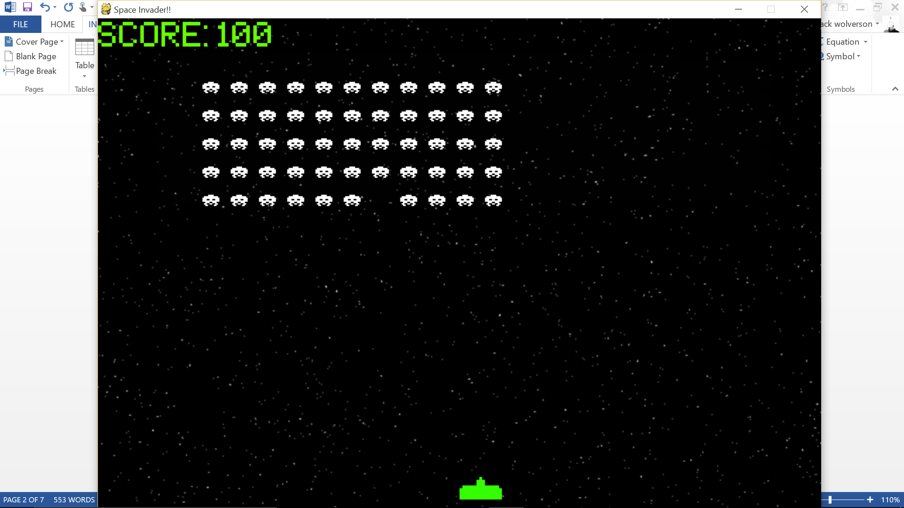

The aliens further down after hitting the right boundary (ss9)

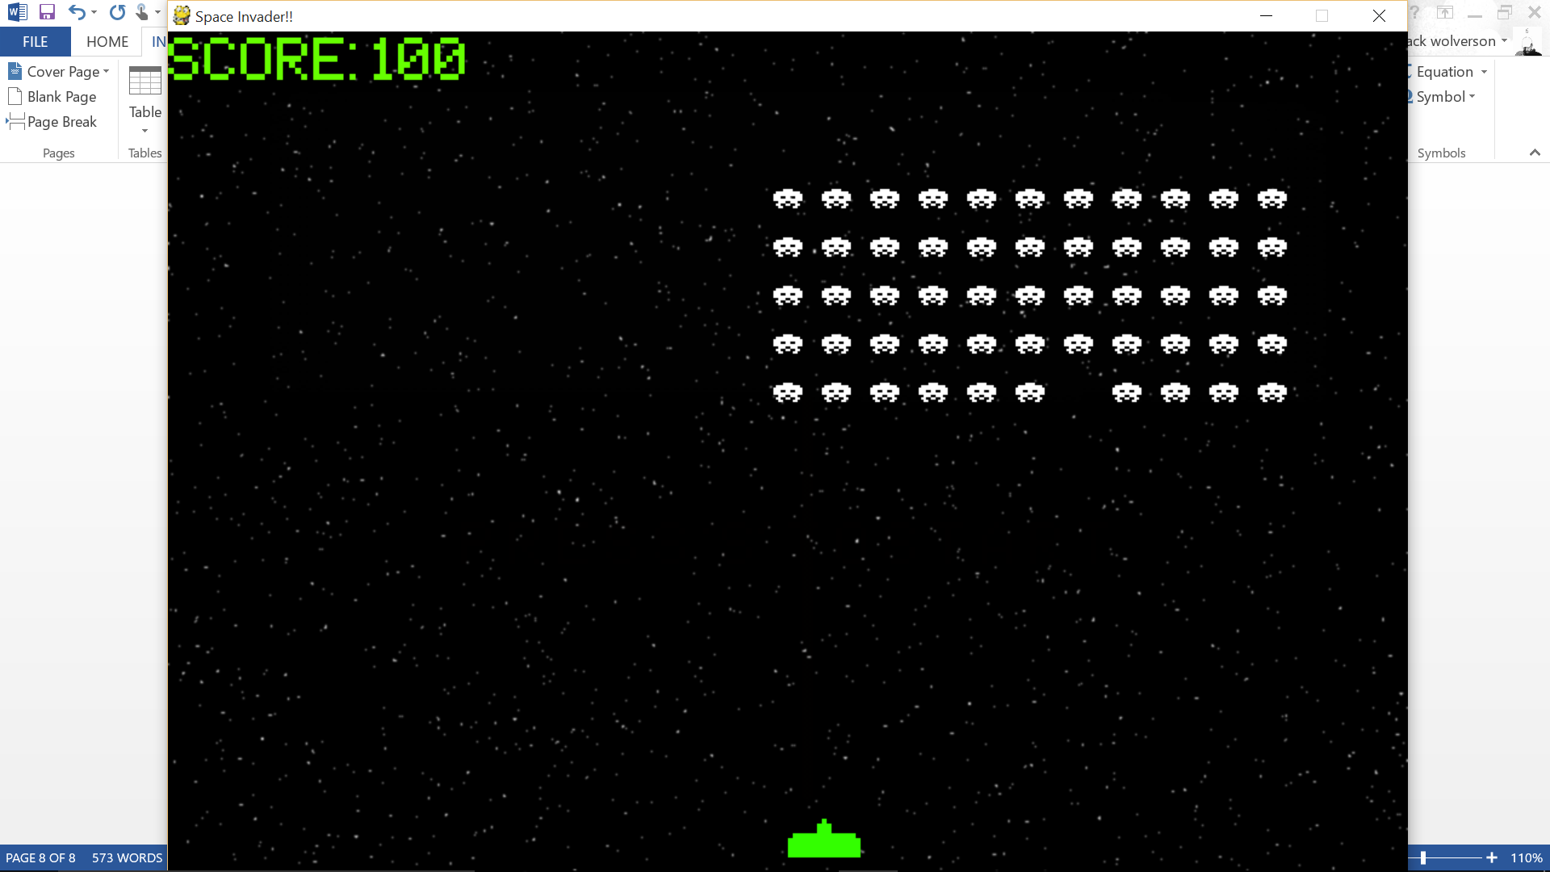

The score updated after the missile hit and the alien was deleted (ss10)

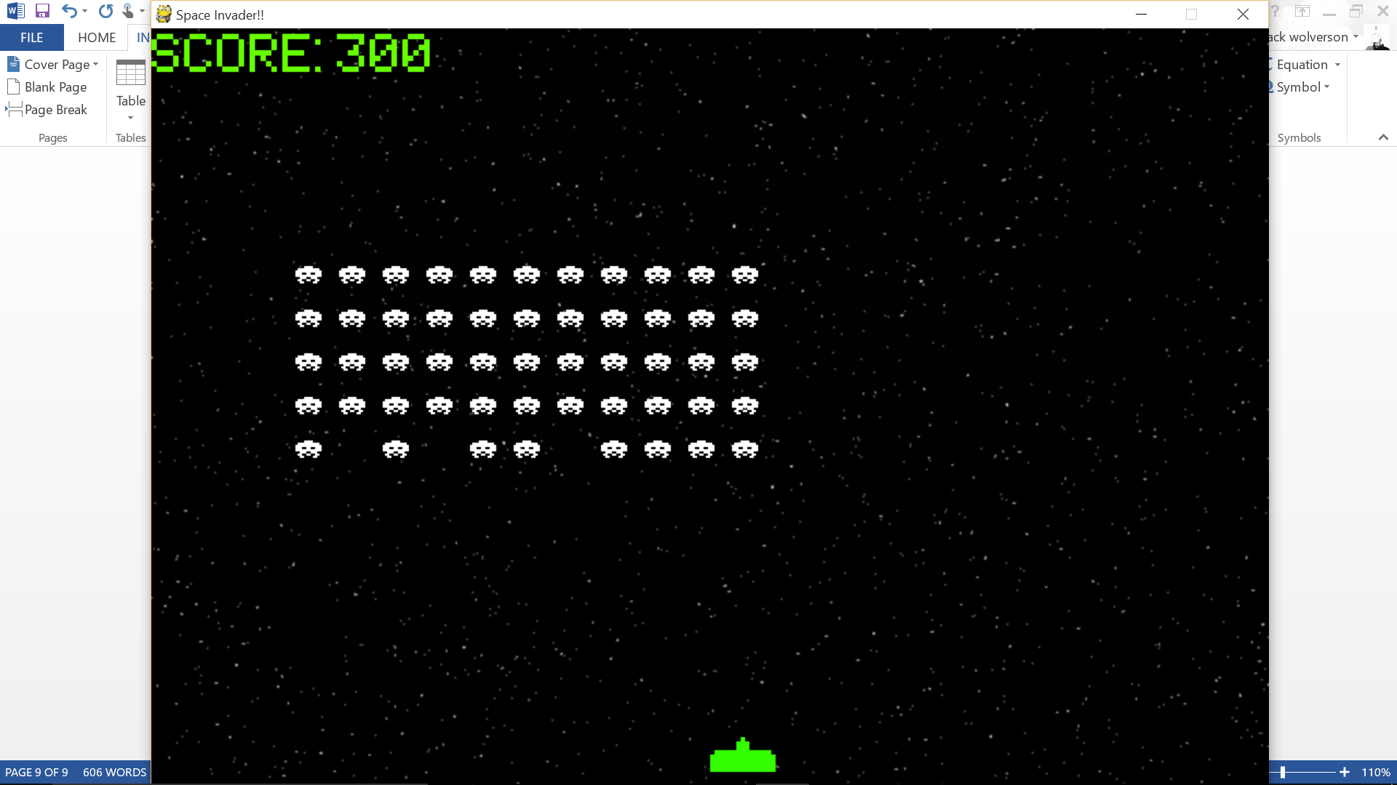

Just before the aliens hit the same level (ss11) 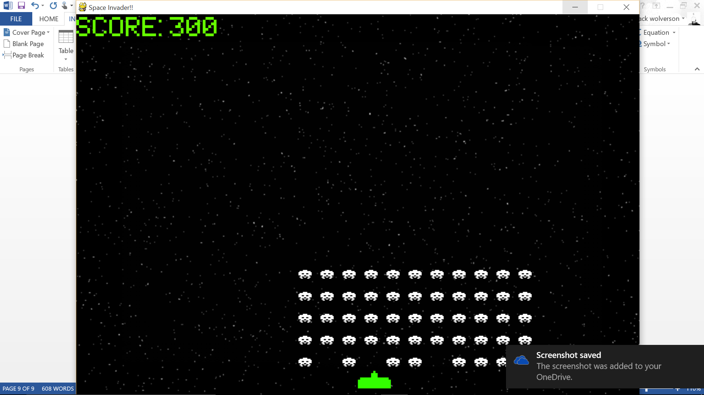

After the aliens hit the same level (ss12)

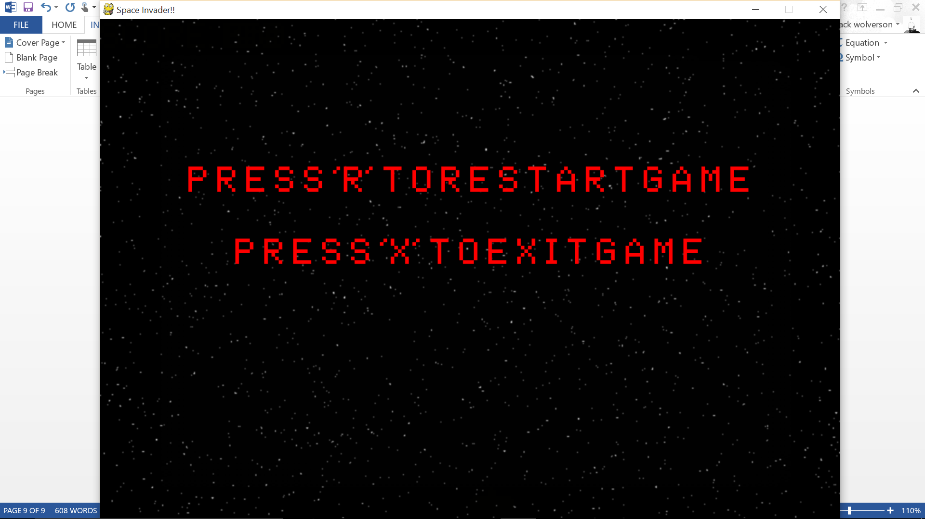

The end screen before any key is pressed (ss13) 

The start screen after the r key has been pressed (ss14)

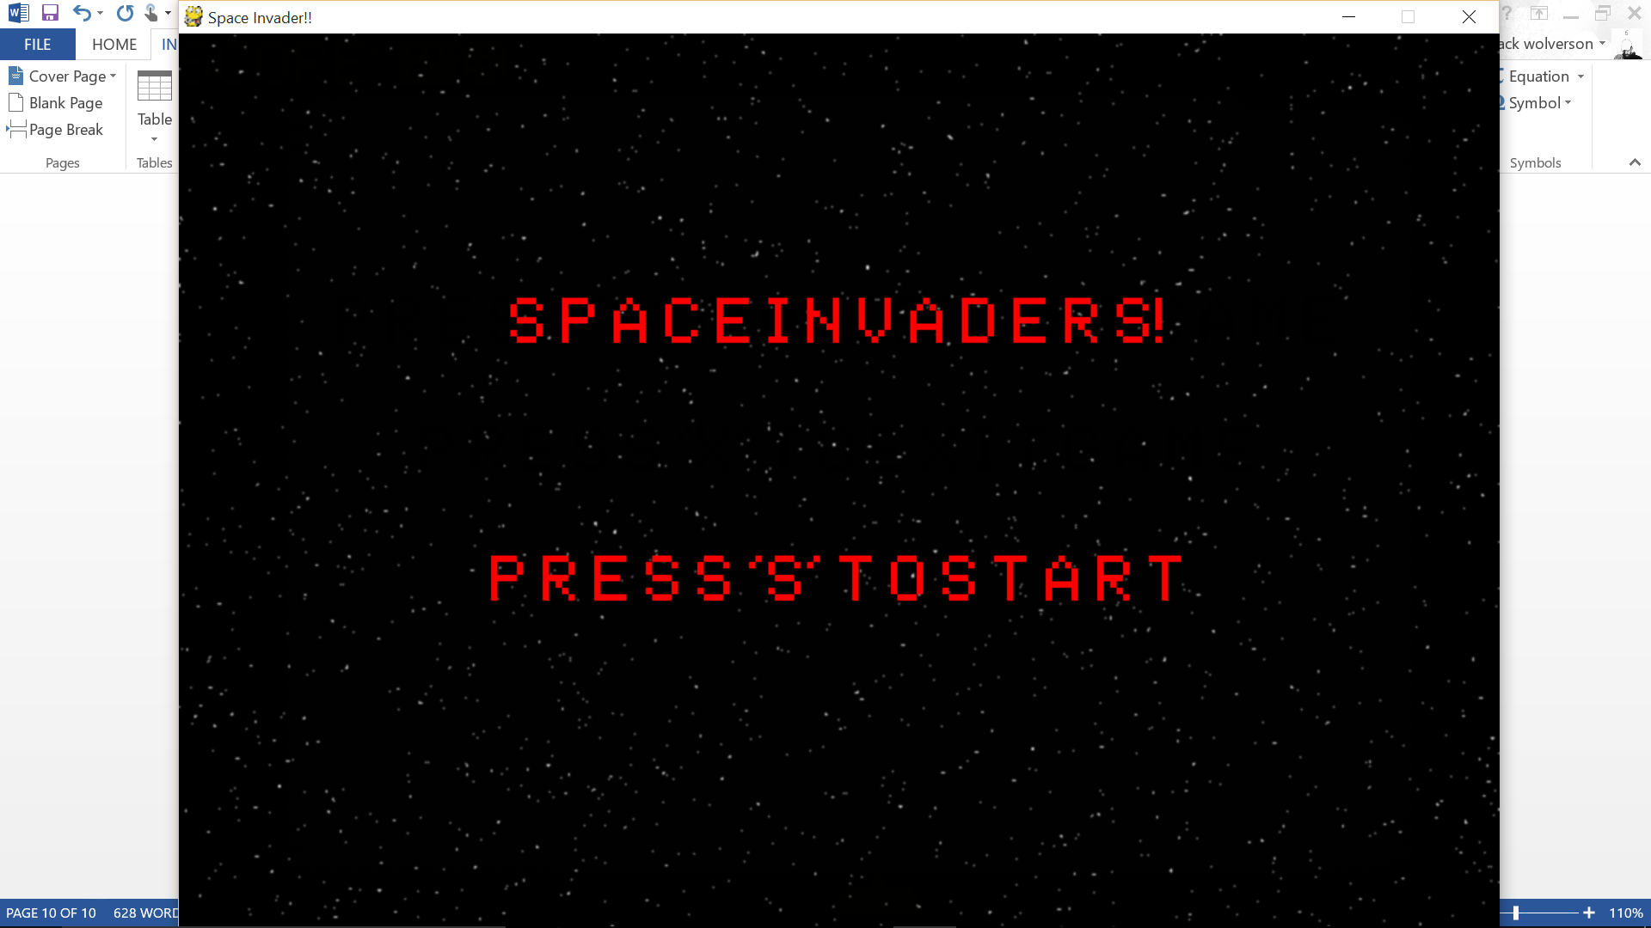

The end screen before any screen has been pressed (ss15)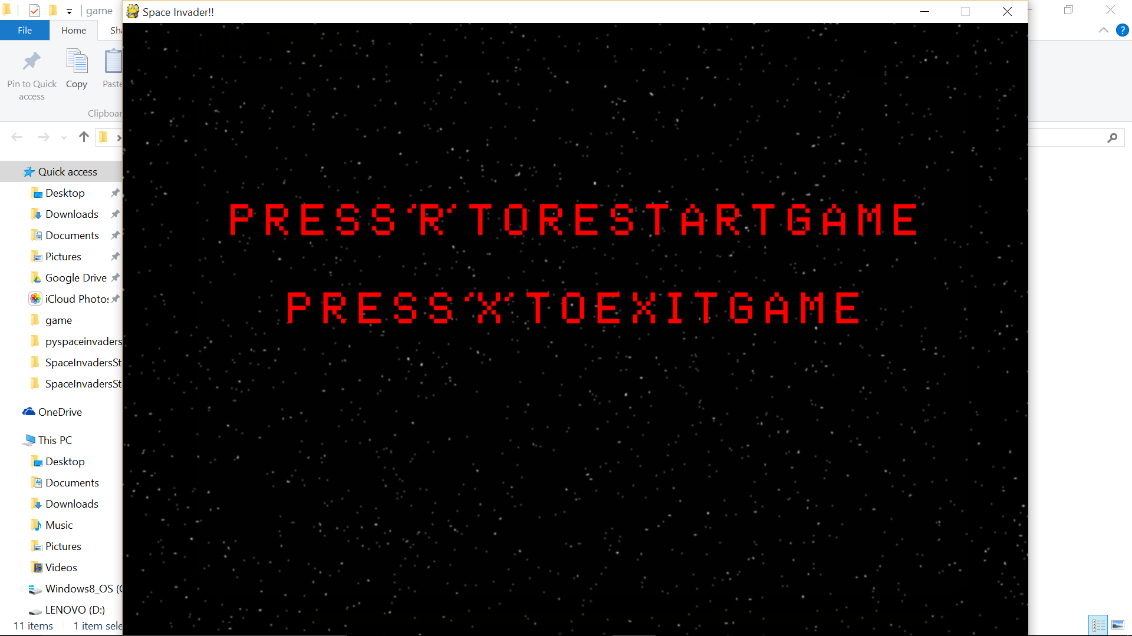

The game closed after the x key has been pressed (no game files open on taskbar) (ss16)

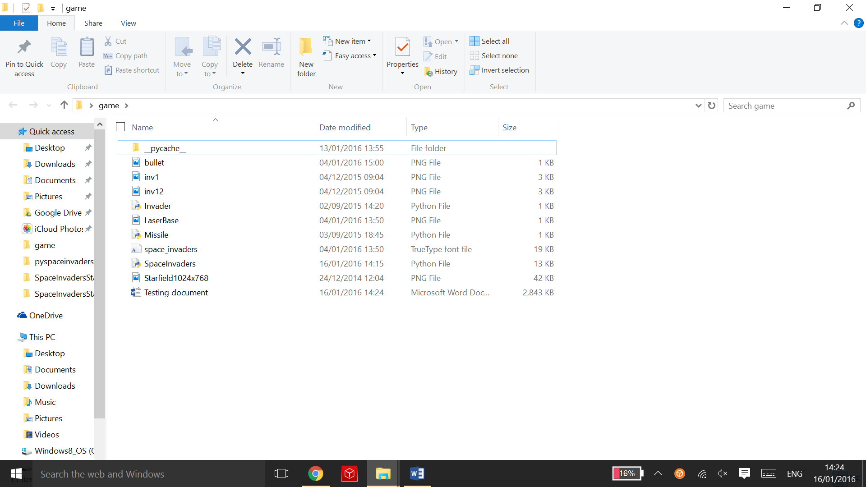

The bug after the game was reset with the score at 600 instead of 300 (ss17)

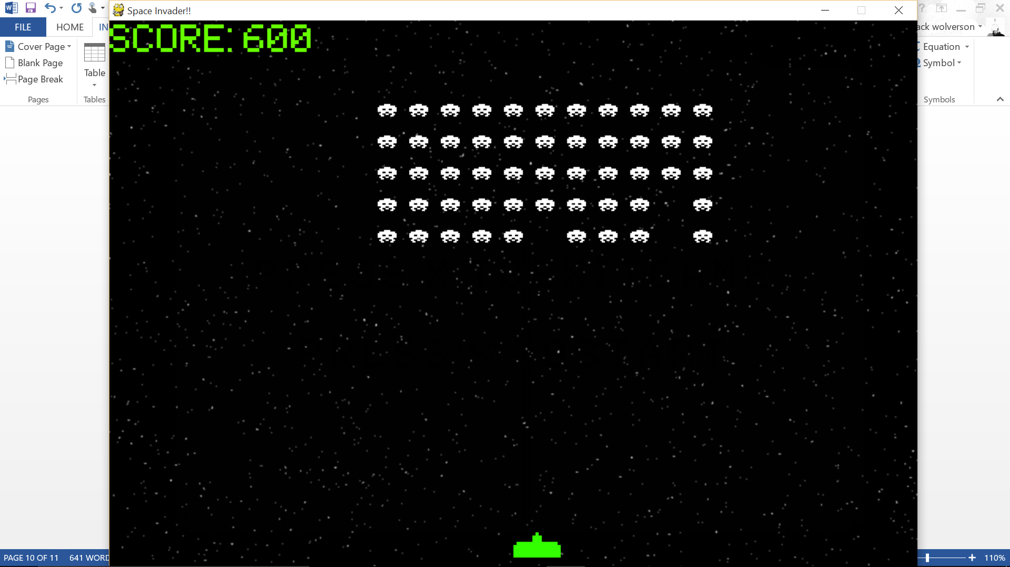

Game score before game restart (ss18)

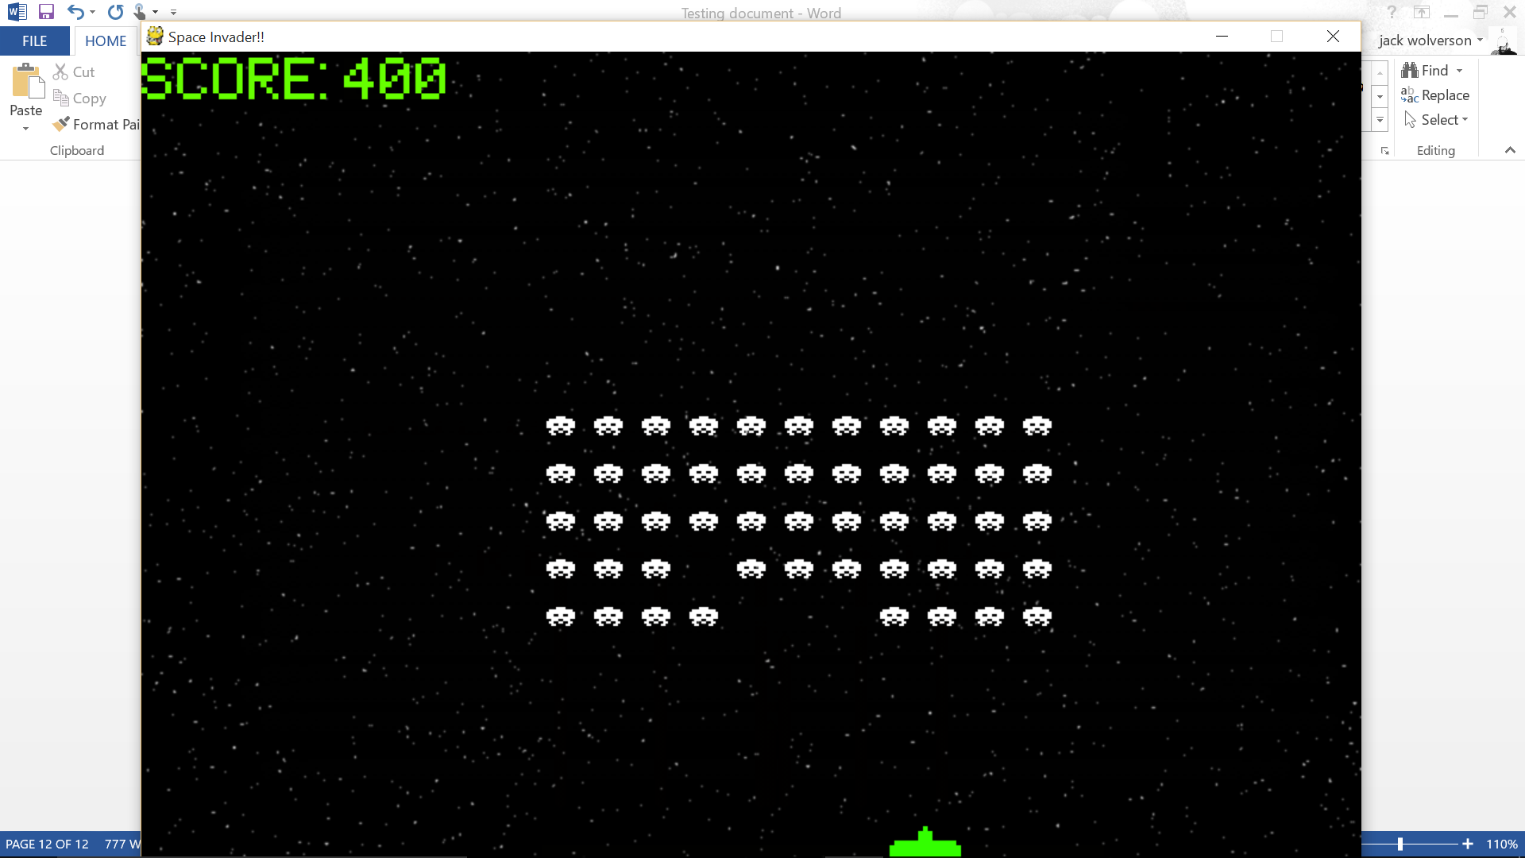

Game score after restart (ss19)

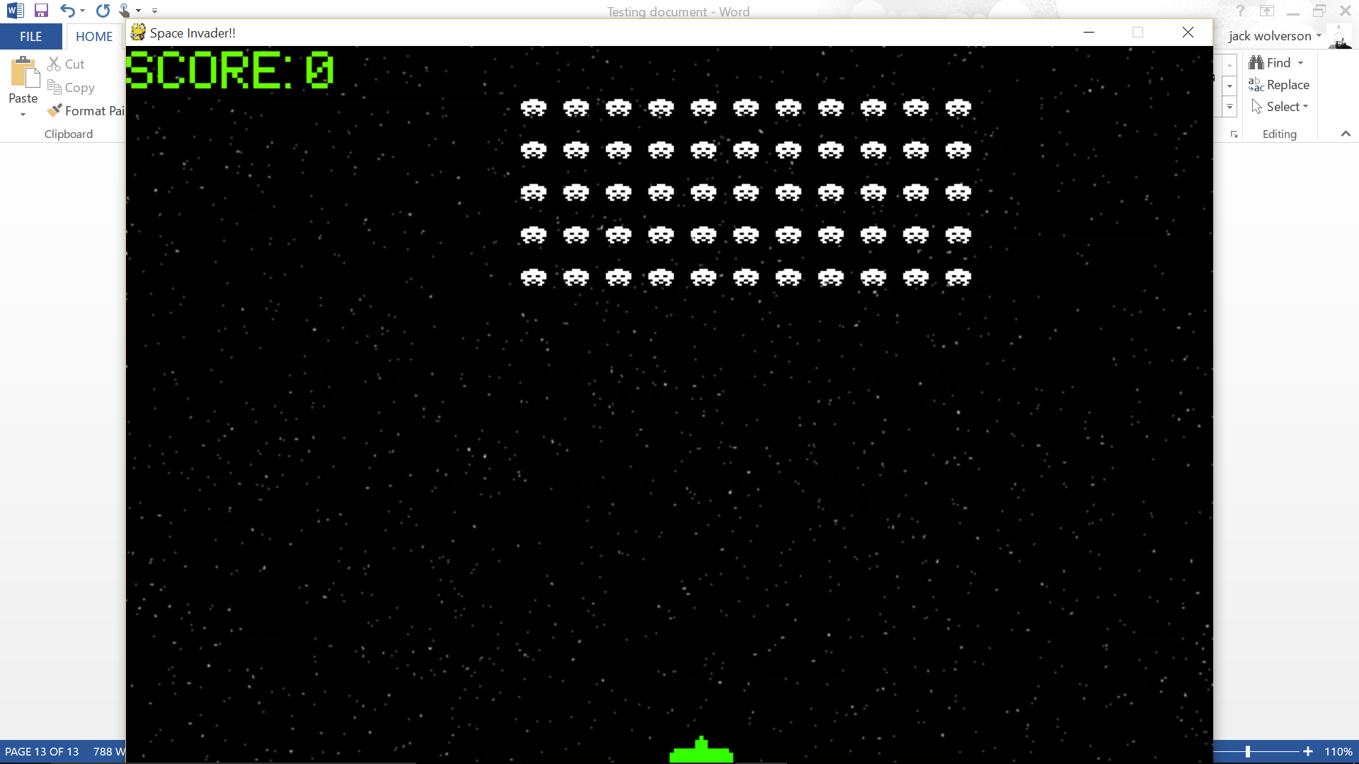

Showing that the missile shot from the left of the rocket(ss20)

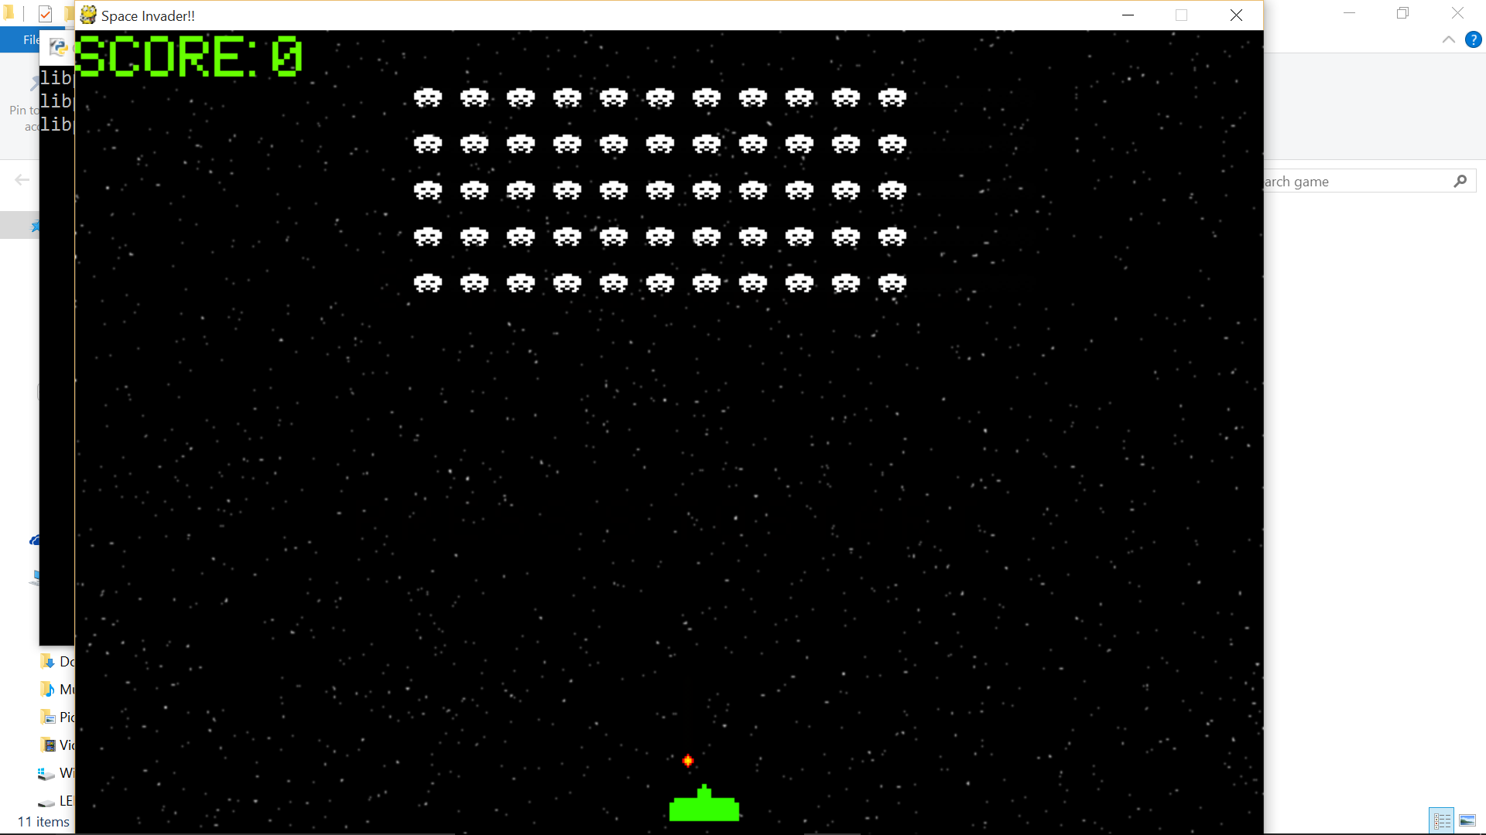

The fixed missile so it shoots from the middle of the player (ss21)

